
Tertiary Infotech Academy Pte Ltd
UEN: 201200696W
WRITTEN ASSESSMENT (SAQ)
For
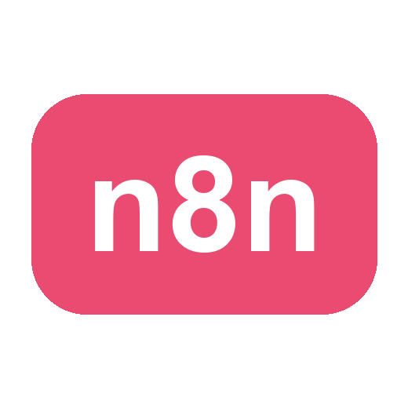
Agentic AI Automation with n8n
TGS Ref No: TGS-2023035977
Conducted by
Tertiary Infotech Academy Pte Ltd
UEN: 201200696W
Version v5

DOCUMENT VERSION CONTROL RECORD
Version Number | Effective Date of Release | Summary of Included Changes | Author
v5 | 1 July 2026 | Aligned all 12 SAQ knowledge questions to the current slides (triggers, action nodes, AI-agent components, RAG, embeddings & the 1536 vector-dimension rule, persistent vector databases, guardrails, webhooks, LLM providers); added the WSQ cover page + version control; standardised the version across the question paper and answer key | Tertiary Infotech Academy Pte Ltd

Agentic AI Automation with n8n
Written Assessment (SAQ)
Course Code: TGS-2023035977
A: Trainee Information
Trainee Name (as per NRIC): ______________________________________
Last 3 digits and alphabet of NRIC/FIN: ____________________
Date: ____________________
B: Instructions to Candidate
1. This is an individual exercise.
2. This is an open-book assessment.
3. A total of 1 hour is given to complete this assessment.
4. Submit your answers on the document provided.
C: Short-Answer Questions (Knowledge)
Answer all questions in your own words. Each question tests underpinning knowledge covered in the course slides.
Question 1:
Generative AI systems are typically designed to produce content in response to user prompts, while agentic AI systems are built to plan, decide, and take actions autonomously to achieve goals over multiple steps.
What are the key differences between Generative AI and Agentic AI in terms of capabilities, behaviour and use cases? (K1)

Question 2:
In n8n, workflows can be started in different ways depending on how and when automation should occur — by a user action, a time-based event, or a request from an external system.
What are the key trigger nodes in n8n that can be used to start a workflow? (K2)

Question 3:
After a workflow is triggered, action nodes process data, apply logic and control the flow — enabling decision-making, branching, data handling and custom logic.
What are some key action / logic nodes in n8n used to control workflow logic and data processing? (K3)

Question 4:
An AI agent perceives context, reasons about a task and takes actions autonomously to achieve a goal. To work, it must combine reasoning with memory and the ability to use external systems.
What are the key components required to build a functional AI agent in n8n? (K4)

Question 5:
You are building an AI system that must retrieve relevant information from your own documents and use that context to generate accurate, up-to-date answers with an LLM — improving factual grounding and reducing hallucination without retraining the model.
Which type of AI workflow best supports this combination of information retrieval and language generation, and how does it work? (K5)

Question 6:
You are designing an n8n workflow that must fetch data from external systems and online services (e.g. a market-data or news API) and use the returned data in later steps.
Which method would you use in n8n to connect to external data sources and services, and what do you configure on it? (K6)

Question 7:
In a RAG system, text must be turned into a form that supports meaning-based (semantic) search before it can be stored and retrieved.
Explain how embeddings and a vector store enable semantic retrieval in a RAG pipeline. (K7)

Question 8:
You try to upload documents into a vector store for RAG, but the ingestion fails or the vectors are rejected. The store was already initialised with a specific embedding configuration.
What is the most likely underlying issue to check first, and what is the rule? (K8)

Question 9:
An in-memory vector store is simple but is lost when the workflow restarts. For production RAG you want a store that persists and scales.
Name persistent vector databases you can use for RAG in n8n, and one distinguishing trait of each. (K9)

Question 10:
To make an AI agent trustworthy, you place safety checks around it so that unsafe input never reaches the agent and unsafe output never reaches the user.
What is the difference between an input (pre) guardrail and an output (post) guardrail, and what does each block? (K10)

Question 11:
Some workflows must start automatically the moment an event happens outside n8n — a form submission, a website chat message, or a call from another application — rather than on a schedule or manual run.
What is the primary purpose of a Webhook in n8n, and what node pairs with it to reply to the caller? (K11)

Question 12:
n8n lets you connect different Large Language Models (LLMs) through their APIs, depending on the use case, performance needs and provider availability.
List three popular LLM providers commonly used with n8n for AI automation. (K12)

______________________________________________________________________________
For Official Use Only
Candidate has answered all written questions and demonstrated the underpinning knowledge required for the course learning outcomes.
Grade: _______ (C / NYC)
Assessor Name: __________________________ Assessor NRIC: ________________
Date: ________________________ Signature: ____________________

